The experimenters talk about firing a photon at a time?
10 ^ 20 photons emitted every second
In class today, > a Trillion squared emitted

Where do they go? Heat, Window, Tunneling?

Behavior not described by Newtonian Physics

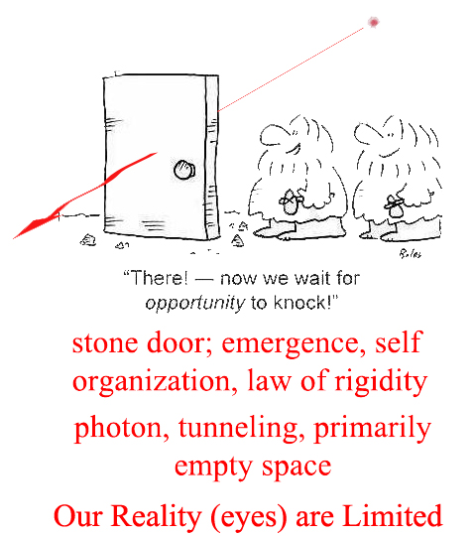
Certainly sound goes through the stone door! Why not other waves? Heat waves go through. But some photons go through the holes between the particles and there are lots of them.
John Bell’s Inequality: considered the most profound lemma
Quantum Mechanics: Most successful theory ever!
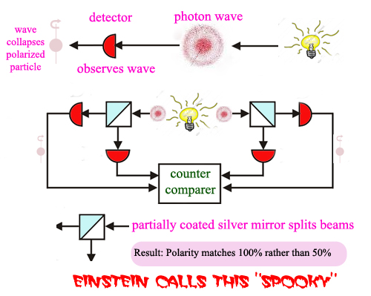

The Implications are Profound and Argumentative
Entanglement is “private.” The “monogamy of entanglement.” Called “passion at a distance.”
How are the pairs of photons connected?
Does information flow faster than the speed of light? Hammeroff/Penrose say no, the photons travel backward in time to communicate.
Some theorize that consciousness occurs in the microtubules in the Brain when the Wave Function Collapses.
Some theorize that at the QM level, the universe is “conscious” of the state of the pair of photons.
What does it mean: the wave function collapses?
It goes from “being everywhere to somewhere”!

Fourier Theory of combining waves
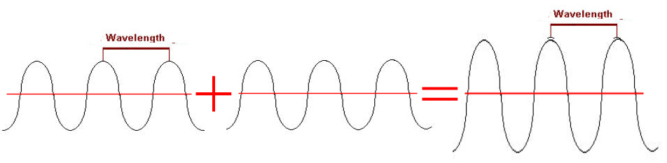
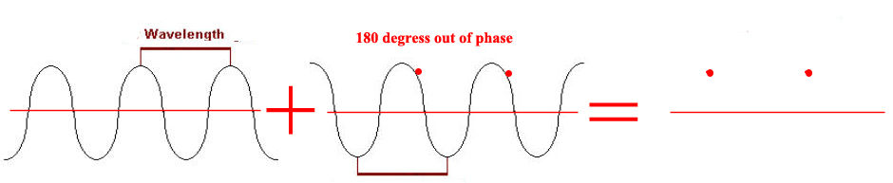

Whitten: leader of string theory, basic vibrating strings with unique harmonics can interact to create unique particles.

